 Project Report Template

**1.INTRODUCTION**

***1.1.overview***

* India is the world’s third-largest producer and consumer of electricity. The national electric grid in India has installed capacity of 370.106 GW as of 31 March 2020. Renewable power plants, which also include large hydroelectric plants, constitute 35.86% of India’s total installed capacity. During the fiscal year (FR) 2019-2020, the total electricity generation in the country was 1,598 TWh, of which 1,383.5 TWh generated by utilities. The gross electricity consumption per capita in FY2019 was 1208kwh.
* In 2015-2016, electric energy consumption in agriculture was recorded as being the highest (17.89%) worldwide. The per capita electricity consumption is low compared to most other countries despite India having a low electricity tariff.
* In light of the recent COVID-19 situation, when everyone has been under lockdown for the months of March to June the impacts of the lockdown on economic activities have been faced by every sector in a positive or negative way.

***1.2.purpose***

* Through this project we can find the regions where electricity consumption is maximum in our country. We need to find out the reasons behind that and try to shortout the problem. So that the electricity consumption will reduce and we can save the electricity for our future generation.

**2. Problem Definition & Design Thinking**

*2.1 Empathy Map*

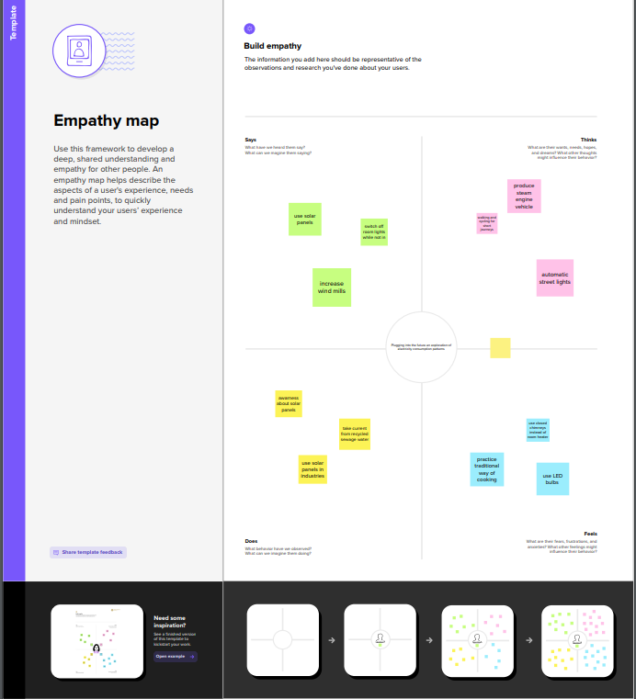

*2.2 Ideation & Brainstorming Map*

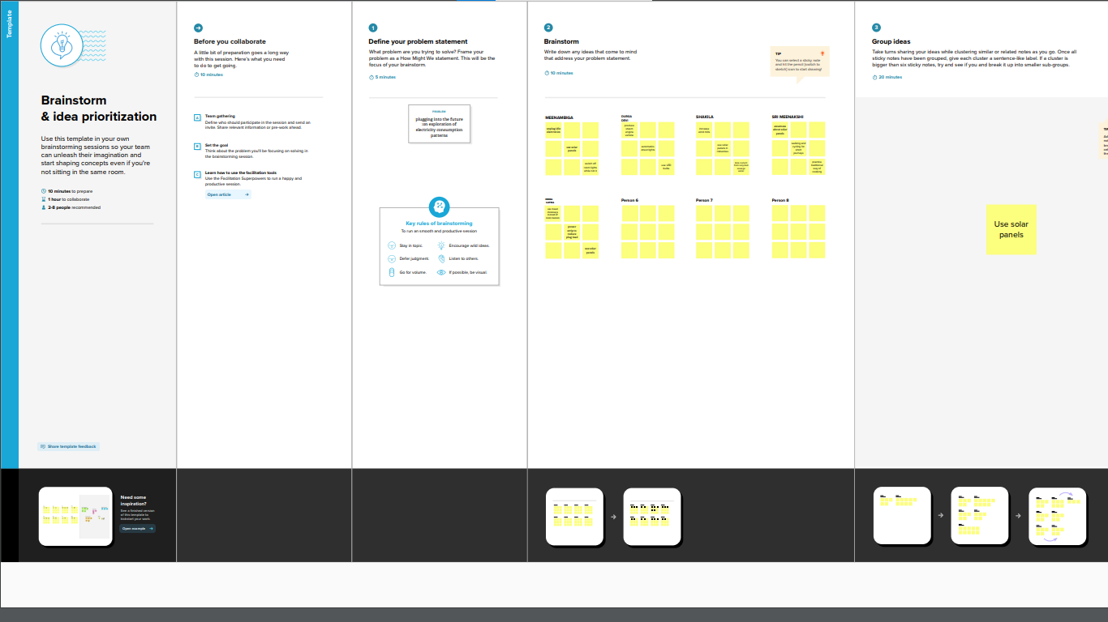

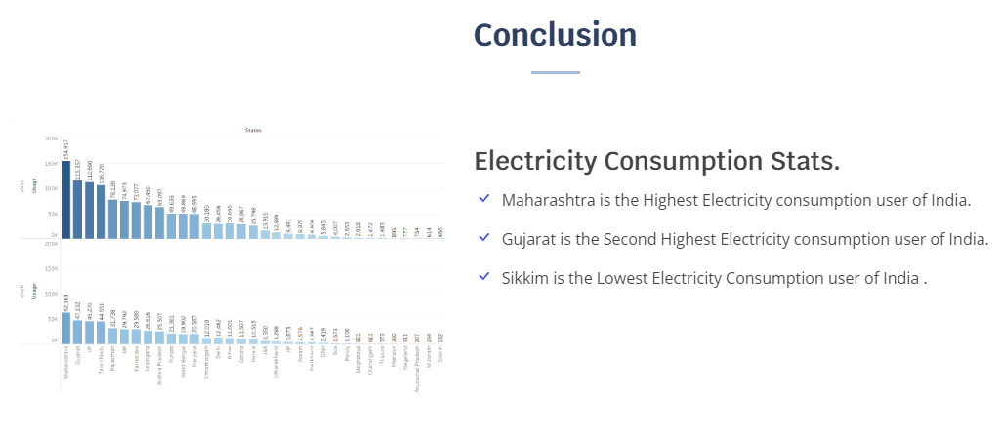**3.RESULT**

**4 ADVANTAGES & DISADVANTAGES**

*AD****ADVANTAGES***

* Electricity is a safe, clean, cheap and convenient source of energy.
* By making an active effort to conserve energy, you understand just how much you actually consume and what benefits it .
* brings to your life.
* Electricity is important for everyone, and children are the future, so we need to teach them, to save electricity.
* Reduces greenhouse emission.
* It is renewable.
* Relatively low maintenance cost.
* We all know that it can be set up in many sizes.

***DISADVANTAGES***

* Sometimes messes up wildlife.
* Changes the quality of river or stream.
* An electric vehicle is not completely emission free.
* Hydroelectric natural seasonal changes in river and
* Ecosystems can be destroyed.
* A lot of radioactive material is released while production of electricity that can be lethal to humans and other organisms.

**4. APPLICATIONS**

* Shut down your computer. Computers are some of the biggest energy users in office buildings
* Choose the right light. LED bulbs are the most efficient lighting option. LED bulbs use 75% less electricity than incandescent bulbs.
* Eliminate vampire power: unplug idle electronics. Devices like televisions, microwaves, scanners, and printers use standby power, even when off.
* Turn off the lights.
* Use a power strip to reduce your plug load. To avoid paying for this “vampire power,” use a power strip to turn all devices off at once.

1. CONCLUSION

* Maharashtra is the highest electricity consumption user of India.
* Gujarat is the second highest electricity consumption user of India.
* Sikkim is the lowest electricity consumption user of India.

**FUTURE SCOPE**

* Elimination and optimization of thermal processes such as hot filling or tunnel pasteurization.
* Cold-fill technologies reduce energy costs providing microbiological safety without compromising on the sensory profile of the product.
* The omission of chilled chain distribution lowers energy consumption ang logistics complexity at the same time.
* Increase packaging flexibility, especially lightweight for a cost and energy efficient choice.
* Easy integration into new and existing production lines increasing utilization rates while lowering CAPEX requirements.

**APPENDIX**

***A. Source Code***

